

Project Title : Movie and TV series info system

Submitted To :  Md Mehrab Hossain Opi Lecturer  Department of Computer Science And Engineering  Waliul Islam Sumon Lecturer  Department of Computer Science And Engineering | Submitted By :  Name : Ankon Roy  Roll 2107113  Department : Computer Science And  Engineering  Course Title : Database Systems Laboratory  Course No : CSE 3110 Date : 09-09-2024

Abstract
This project aims to develop a comprehensive database system for storing and managing information about movies and TV series. The database captures details such as titles, genres, casts, release dates, runtime, ratings, and reviews. It provides a structured way to store data efficiently, supports queries for retrieving information, and allows for future enhancements such as recommendation systems or integration with streaming platforms.

Introduction
The entertainment industry generates vast amounts of data daily, including movies, TV series, cast members, and user reviews. Managing this data manually is inefficient and error-prone. This project focuses on creating a relational database system to store and manage such information efficiently. The database supports queries for retrieving media details, cast information, genre classifications, and ratings.

Objectives
- To store detailed information about movies and TV series.
- To maintain relationships between media, genres, and cast members.
- To support data retrieval through structured queries.
- To enable future integration with applications such as streaming platforms or recommendation engines.

Requirement Analysis

Functional Requirements
- Store information about media (movies/TV series).
- Store information about genres.
- Maintain cast and crew information.
- Allow querying media by release date, genre, or cast.
- Store ratings and reviews.

Non-Functional Requirements
- Data integrity through constraints and relationships.
- Efficient query execution.
- Scalability for large datasets.

Database Design
The database uses a relational model with the following primary entities:
1. Media: Stores general information about movies and TV series.
2. Genre: Stores genre names and descriptions.
3. Media_Genre: Many-to-many relationship between media and genres.
4. Cast: Stores actors, directors, and other contributors.
5. Media_Cast: Many-to-many relationship between media and cast members.

Schema Description

Media Table
Column | Type | Constraints
media_id | NUMBER | PRIMARY KEY
title | VARCHAR2(255) | NOT NULL
overview | CLOB
release_date | DATE
runtime | NUMBER
media_type | VARCHAR2(10) | NOT NULL

Genre Table
Column | Type | Constraints
genre_id | NUMBER | PRIMARY KEY
name | VARCHAR2(50) | NOT NULL, UNIQUE

Media_Genre Table
Column | Type | Constraints
media_id | NUMBER | FOREIGN KEY REFERENCES Media(media_id)
genre_id | NUMBER | FOREIGN KEY REFERENCES Genre(genre_id)

Cast Table
Column | Type | Constraints
cast_id | NUMBER | PRIMARY KEY
name | VARCHAR2(255) | NOT NULL
role | VARCHAR2(100) | NOT NULL

Media_Cast Table
Column | Type | Constraints
media_id | NUMBER | FOREIGN KEY REFERENCES Media(media_id)
cast_id | NUMBER | FOREIGN KEY REFERENCES Cast(cast_id)

Schema Diagram
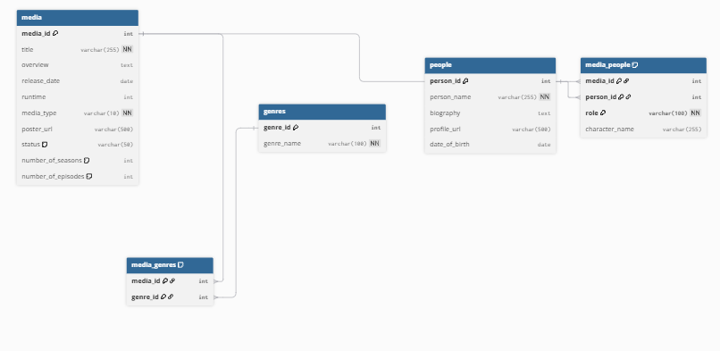

ER Diagram
